|  |
| --- |
| **CS4313** |
| Deliverable 2 |
|  |
| All Database tables |
|  |
|  |
|  |
|  |
| **David O Neill 0813001** |
| **James McHugh 0052833** |
| **Keiran Duggan 0866504** |
|  |
| **12/3/2010** |
|  |

Table of Contents

Database 2

Tables 2

Auction items 3

Auction pictures 5

Auction categories 5

Auction sub categories 6

Item searching 6

Messages 7

Auction Bids 8

Item watching 9

Auction feedback 10

Addresses 11

OU users 12

OU groups 13

Countries 13

Locale 13

Referential Integrity Constraints 14

SQL 14

Overview 15

Relations Overview 15

# Database

## Tables

### Auction items

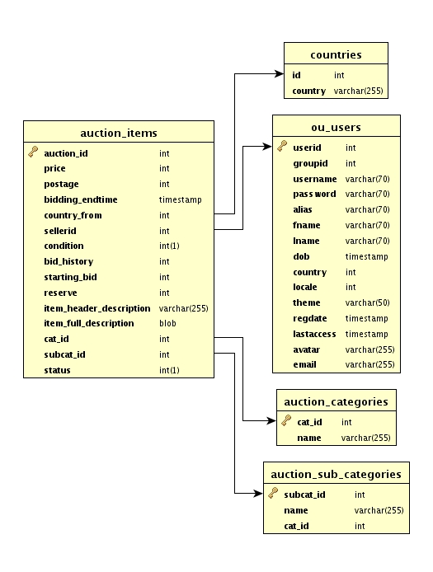

#### SQL

CREATE TABLE auction_items (

auction_id int(11) NOT NULL AUTO_INCREMENT,

price int(11) NOT NULL,

postage int(11) NOT NULL,

bidding_endtime timestamp NOT NULL DEFAULT CURRENT_TIMESTAMP,

country_from int(11) NOT NULL,

sellerid int(11) NOT NULL,

`condition` int(1) NOT NULL,

bid_history int(11) NOT NULL,

starting_bid int(11) NOT NULL,

reserve int(11) NOT NULL,

item_header_description varchar(255) NOT NULL,

item_full_description blob NOT NULL,

cat_id int(11) NOT NULL,

subcat_id int(11) NOT NULL,

`status` int(1) NOT NULL,

PRIMARY KEY (auction_id),

KEY country_from (country_from),

KEY sellerid (sellerid),

KEY cat_id (cat_id),

KEY subcat_id (subcat_id)

) ENGINE=InnoDB DEFAULT CHARSET=latin1;

### Auction pictures

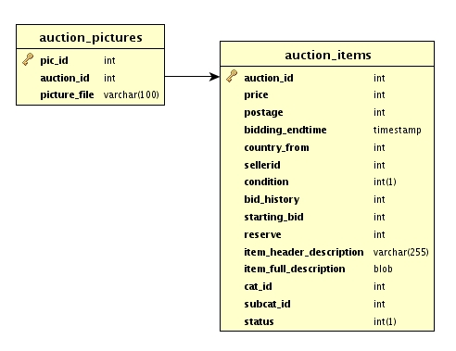

#### SQL

CREATE TABLE auction_pictures (

pic_id int(11) NOT NULL AUTO_INCREMENT,

auction_id int(11) NOT NULL,

picture_file varchar(100) NOT NULL,

PRIMARY KEY (pic_id),

KEY auction_id (auction_id)

) ENGINE=InnoDB DEFAULT CHARSET=latin1;

$salt = microtime(); // unix timestamp + microsseconds

$picure_file= $salt . $_FILES['uploadedfile']['name']; // unique enough?

We want to keep the file extension ( MIME types ), using a number will assume all upload with be same extension.

### Auction categories

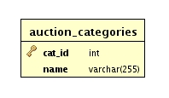

#### SQL

CREATE TABLE `auction_categories` (

`cat_id` int(11) NOT NULL AUTO_INCREMENT,

`name` varchar(255) NOT NULL,

PRIMARY KEY (`cat_id`)

) ENGINE=InnoDB DEFAULT CHARSET=latin1 AUTO_INCREMENT=1 ;

### Auction sub categories

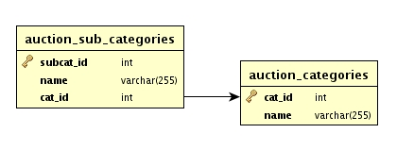

#### SQL

CREATE TABLE `auction_sub_categories` (

`subcat_id` int(11) NOT NULL AUTO_INCREMENT,

`name` varchar(255) NOT NULL,

`cat_id` int(11) NOT NULL,

PRIMARY KEY (`subcat_id`),

KEY `cat_id` (`cat_id`)

) ENGINE=InnoDB DEFAULT CHARSET=latin1 AUTO_INCREMENT=1 ;

### Item searching

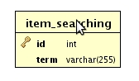

#### SQL

CREATE TABLE `item_searching` (

`id` int(11) NOT NULL AUTO_INCREMENT,

`term` varchar(255) NOT NULL,

PRIMARY KEY (`id`)

) ENGINE=InnoDB DEFAULT CHARSET=latin1 AUTO_INCREMENT=1 ;

### Messages

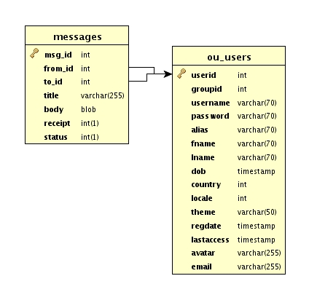

#### SQL

CREATE TABLE `messages` (

`msg_id` int(11) NOT NULL AUTO_INCREMENT,

`from_id` int(11) NOT NULL,

`to_id` int(11) NOT NULL,

`title` varchar(255) NOT NULL,

`body` blob NOT NULL,

`receipt` int(1) NOT NULL,

`status` int(1) NOT NULL,

PRIMARY KEY (`msg_id`),

KEY `from_id` (`from_id`),

KEY `to_id` (`to_id`)

) ENGINE=InnoDB DEFAULT CHARSET=latin1 AUTO_INCREMENT=1 ;

### Auction Bids

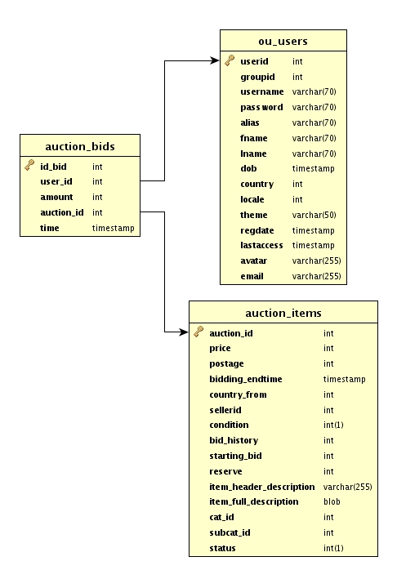

#### SQL

CREATE TABLE auction_bids (

id_bid int(11) NOT NULL AUTO_INCREMENT,

user_id int(11) NOT NULL,

amount int(11) NOT NULL,

auction_id int(11) NOT NULL,

`time` timestamp NOT NULL DEFAULT CURRENT_TIMESTAMP,

PRIMARY KEY (id_bid),

KEY auction_id (auction_id),

KEY user_id (user_id)

) ENGINE=InnoDB DEFAULT CHARSET=latin1;

### Item watching

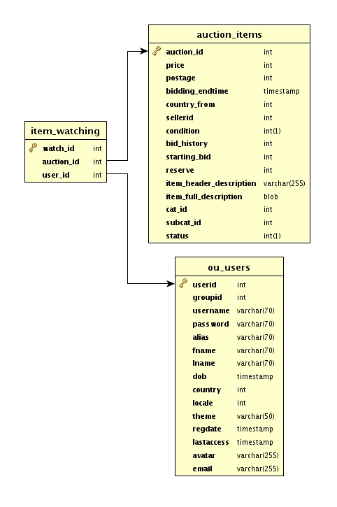

#### SQL

CREATE TABLE `item_watching` (

`watch_id` int(11) NOT NULL AUTO_INCREMENT,

`auction_id` int(11) NOT NULL,

`user_id` int(11) NOT NULL,

PRIMARY KEY (`watch_id`),

KEY `auction_id` (`auction_id`),

KEY `user_id` (`user_id`)

) ENGINE=InnoDB DEFAULT CHARSET=latin1 AUTO_INCREMENT=1 ;

### Auction feedback

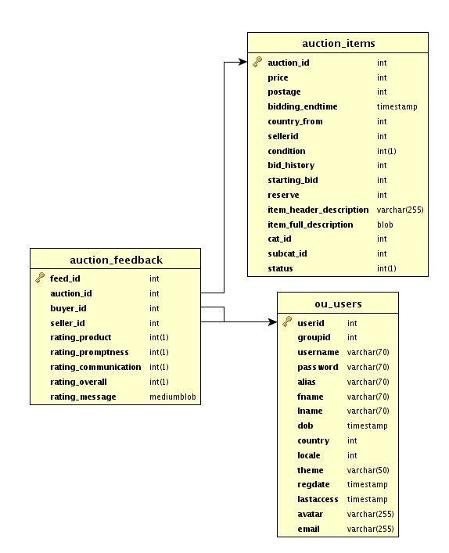

#### SQL

CREATE TABLE `auction_feedback` (

`feed_id` int(11) NOT NULL AUTO_INCREMENT,

`auction_id` int(11) NOT NULL,

`buyer_id` int(11) NOT NULL,

`seller_id` int(11) NOT NULL,

`rating_product` int(1) NOT NULL,

`rating_promptness` int(1) NOT NULL,

`rating_communication` int(1) NOT NULL,

`rating_overall` int(1) NOT NULL,

`rating_message` mediumblob NOT NULL,

PRIMARY KEY (`feed_id`),

KEY `auction_id` (`auction_id`),

KEY `buyer_id` (`buyer_id`),

KEY `seller_id` (`seller_id`)

) ENGINE=InnoDB DEFAULT CHARSET=latin1 AUTO_INCREMENT=1 ;

### Addresses

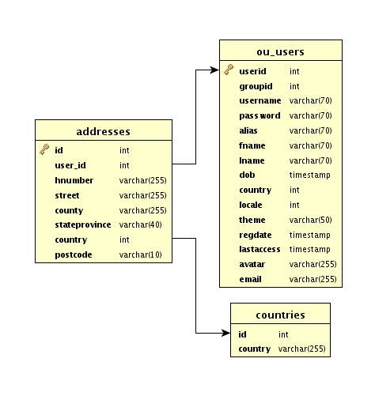

#### SQL

CREATE TABLE `addresses` (

`id` int(11) NOT NULL AUTO_INCREMENT,

`user_id` int(11) NOT NULL,

`hnumber` varchar(255) NOT NULL,

`street` varchar(255) NOT NULL,

`county` varchar(255) NOT NULL,

`stateprovince` varchar(40) NOT NULL,

`country` int(11) NOT NULL,

`postcode` varchar(10) NOT NULL,

PRIMARY KEY (`id`),

KEY `user_id` (`user_id`),

KEY `country` (`country`)

) ENGINE=InnoDB DEFAULT CHARSET=latin1 AUTO_INCREMENT=1 ;

### OU users

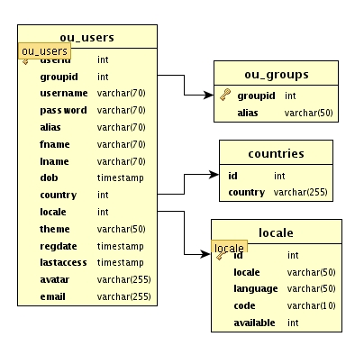

#### SQL

CREATE TABLE ou_users (

userid int(11) NOT NULL AUTO_INCREMENT,

groupid int(11) NOT NULL,

username varchar(70) NOT NULL,

`password` varchar(70) NOT NULL,

alias varchar(70) NOT NULL,

fname varchar(70) NOT NULL,

lname varchar(70) NOT NULL,

dob timestamp NOT NULL DEFAULT '0000-00-00 00:00:00',

country int(11) NOT NULL,

locale int(11) NOT NULL,

theme varchar(50) NOT NULL,

regdate timestamp NOT NULL DEFAULT CURRENT_TIMESTAMP,

lastaccess timestamp NOT NULL DEFAULT '0000-00-00 00:00:00',

avatar varchar(255) NOT NULL,

email varchar(255) NOT NULL,

PRIMARY KEY (userid),

KEY groupid (groupid),

KEY country (country),

KEY locale (locale)

) ENGINE=InnoDB DEFAULT CHARSET=latin1;

### OU groups

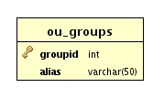

#### SQL

CREATE TABLE `ou_groups` (

`groupid` int(11) NOT NULL AUTO_INCREMENT,

`alias` varchar(50) NOT NULL,

PRIMARY KEY (`groupid`)

) ENGINE=InnoDB DEFAULT CHARSET=latin1 AUTO_INCREMENT=7 ;

### Countries

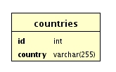

#### SQL

CREATE TABLE `countries` (

`id` int(11) NOT NULL,

`country` varchar(255) NOT NULL,

KEY `id` (`id`)

) ENGINE=InnoDB DEFAULT CHARSET=latin1;

### Locale

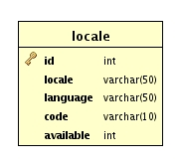

#### SQL

CREATE TABLE `locale` (

`id` int(11) NOT NULL AUTO_INCREMENT,

`locale` varchar(50) NOT NULL,

`language` varchar(50) NOT NULL,

`code` varchar(10) NOT NULL,

`available` int(11) NOT NULL,

PRIMARY KEY (`id`)

) ENGINE=InnoDB DEFAULT CHARSET=latin1 AUTO_INCREMENT=93 ;

## Referential Integrity Constraints

### SQL

## ALTER TABLE `addresses`

## ADD CONSTRAINT addresses_ibfk_1 FOREIGN KEY (user_id) REFERENCES ou_users (userid),

## ADD CONSTRAINT addresses_ibfk_2 FOREIGN KEY (country) REFERENCES countries (id);

## ALTER TABLE `auction_bids`

## ADD CONSTRAINT auction_bids_ibfk_1 FOREIGN KEY (user_id) REFERENCES ou_users (userid),

## ADD CONSTRAINT auction_bids_ibfk_2 FOREIGN KEY (auction_id) REFERENCES auction_items (auction_id);

## ALTER TABLE `auction_feedback`

## ADD CONSTRAINT auction_feedback_ibfk_1 FOREIGN KEY (auction_id) REFERENCES auction_items (auction_id),

## ADD CONSTRAINT auction_feedback_ibfk_2 FOREIGN KEY (buyer_id) REFERENCES ou_users (userid),

## ADD CONSTRAINT auction_feedback_ibfk_3 FOREIGN KEY (seller_id) REFERENCES ou_users (userid);

## ALTER TABLE `auction_items`

## ADD CONSTRAINT auction_items_ibfk_1 FOREIGN KEY (country_from) REFERENCES countries (id),

## ADD CONSTRAINT auction_items_ibfk_2 FOREIGN KEY (sellerid) REFERENCES ou_users (userid),

## ADD CONSTRAINT auction_items_ibfk_3 FOREIGN KEY (cat_id) REFERENCES auction_categories (cat_id),

## ADD CONSTRAINT auction_items_ibfk_4 FOREIGN KEY (subcat_id) REFERENCES auction_sub_categories (subcat_id);

## ALTER TABLE `auction_pictures`

## ADD CONSTRAINT auction_pictures_ibfk_1 FOREIGN KEY (auction_id) REFERENCES auction_items (auction_id);

## ALTER TABLE `auction_sub_categories`

## ADD CONSTRAINT auction_sub_categories_ibfk_1 FOREIGN KEY (cat_id) REFERENCES auction_categories (cat_id);

## ALTER TABLE `item_watching`

## ADD CONSTRAINT item_watching_ibfk_1 FOREIGN KEY (auction_id) REFERENCES auction_items (auction_id),

## ADD CONSTRAINT item_watching_ibfk_2 FOREIGN KEY (user_id) REFERENCES ou_users (userid);

## ALTER TABLE `messages`

## ADD CONSTRAINT messages_ibfk_1 FOREIGN KEY (from_id) REFERENCES ou_users (userid),

## ADD CONSTRAINT messages_ibfk_2 FOREIGN KEY (to_id) REFERENCES ou_users (userid);

## ALTER TABLE `ou_users`

## ADD CONSTRAINT ou_users_ibfk_1 FOREIGN KEY (groupid) REFERENCES ou_groups (groupid),

## ADD CONSTRAINT ou_users_ibfk_2 FOREIGN KEY (country) REFERENCES countries (id),

## ADD CONSTRAINT ou_users_ibfk_3 FOREIGN KEY (locale) REFERENCES locale (id);

## Overview

### Relations Overview

